Week 4 Report
Predictive Modeling and Optimization in Logistics Systems
Logistics Data Analyst Internship | Yuva Intern
Prepared by: [Your Name] | Date: 06 October 2026

1. Objective
The objective of this task is to apply predictive modeling and optimisation techniques to a logistics problem. A model is built in Python to forecast delivery time, its performance is evaluated using standard regression metrics and cross-validation, and the results are used to propose optimisation strategies for logistics operations.

2. Problem Definition
Accurate delivery-time forecasts allow a logistics company to set realistic customer promises, plan routes and schedule resources. The prediction problem is therefore: given the characteristics of a shipment, predict how many hours its delivery will take. This is a supervised regression problem.

3. Dataset and Variables
The same hypothetical dataset of 1,000 shipments used in Week 3 was used (random seed 42).
- Target variable: delivery_time_hrs
- Features: distance_km, shipment_volume, transport_cost, region and transport_mode (the two categorical variables were one-hot encoded with the first category dropped).
- Train/test split: 80 percent training (800 records) and 20 percent testing (200 records), random_state = 42.

4. Model Selection and Implementation
Three models of increasing flexibility were compared:
- Linear Regression: a simple, interpretable baseline. It is appropriate because the Week 3 analysis showed a strong linear relationship between distance and delivery time.
- Decision Tree Regressor (max_depth = 6): captures non-linear patterns and interactions; depth is limited to reduce overfitting.
- Random Forest Regressor (200 trees): an ensemble of trees that reduces variance and usually generalises better than a single tree.

Code excerpt
X = pd.get_dummies(df.drop(columns="delivery_time_hrs"), drop_first=True)
y = df["delivery_time_hrs"]
X_train, X_test, y_train, y_test = train_test_split(X, y, test_size=0.2, random_state=42)
models = {"Linear Regression": LinearRegression(),
"Decision Tree": DecisionTreeRegressor(max_depth=6, random_state=42),
"Random Forest": RandomForestRegressor(n_estimators=200, random_state=42)}
for name, m in models.items():
m.fit(X_train, y_train); p = m.predict(X_test)
cv = cross_val_score(m, X, y, cv=5, scoring="r2").mean()
print(name, mean_absolute_error(y_test, p),
np.sqrt(mean_squared_error(y_test, p)), r2_score(y_test, p), cv)

5. Evaluation and Validation
Models were evaluated on the held-out test set with three metrics: MAE (average absolute error in hours), RMSE (error measure that penalises large mistakes) and R-squared (share of variance explained). Five-fold cross-validation R-squared was also computed on the full dataset to confirm that results are not an artefact of one particular split.
Model | MAE (hrs) | RMSE (hrs) | R-squared | 5-fold CV R-squared
Linear Regression | 2.33 | 2.91 | 0.911 | 0.907
Decision Tree | 2.49 | 3.1 | 0.899 | 0.874
Random Forest | 2.4 | 3.05 | 0.902 | 0.893

All three models perform well (R-squared between 0.899 and 0.911). Linear Regression is the best model on every metric (MAE 2.33 hrs, RMSE 2.91 hrs, CV R-squared 0.907). This is expected, because the delivery time in this dataset depends linearly on distance, so the extra flexibility of tree-based models does not help. The Random Forest is a close second and is more robust than the single Decision Tree, which has the lowest cross-validation score (0.874) and so generalises least well. The model can predict delivery time to within about 2.33 hours on average.
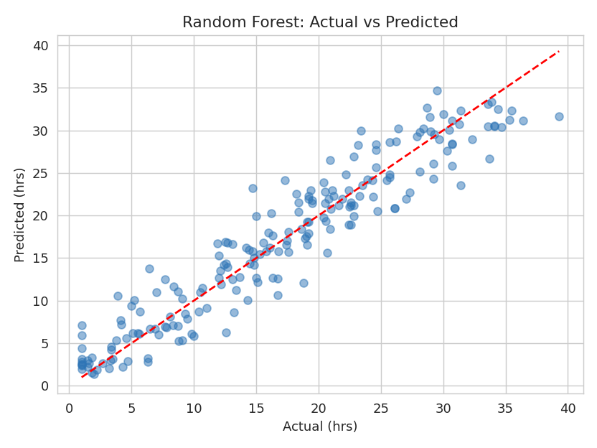
Figure 1: Random Forest, actual versus predicted delivery time
Points lie close to the red diagonal line, showing that predictions track actual delivery times across the whole range.

Hyperparameter and validation notes
- The Decision Tree depth was capped at 6 and the Random Forest uses 200 trees to control overfitting and give stable results.
- Cross-validation scores close to test scores (for example 0.907 versus 0.911 for Linear Regression) indicate no meaningful overfitting.
- Further tuning (for example GridSearchCV over tree depth and number of estimators) could be applied but is unlikely to beat Linear Regression on this data.

6. Feature Importance
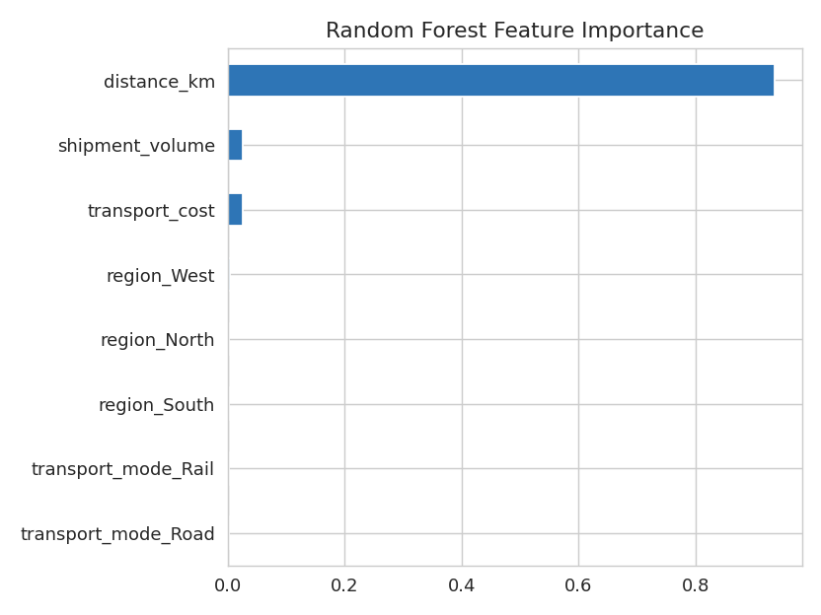
Figure 2: Random Forest feature importance
Distance accounts for 93.5 percent of the Random Forest's predictive importance. Shipment volume and transport cost contribute about 2.6 percent each, and region and transport mode are close to zero. Delivery time is therefore overwhelmingly a function of distance in this dataset.

7. Optimization Strategies
- Route and network optimisation: because distance drives delivery time, shortening routes (consolidated routing, hub locations closer to demand) gives the largest reduction in delivery time.
- Mode selection for cost: rail and sea cost far less than air (average 309.46 for sea and 434.65 for rail versus 1476.94 for air), so non-urgent shipments should be shifted to them.
- Resource allocation by region: West has the highest shipment volume and South the lowest, so vehicles and staff should be allocated in proportion to regional demand.
- Reliable delivery promises: use the model to quote delivery windows, adding a buffer of about one RMSE (2.91 hours) to reduce late deliveries.
- Scheduling and capacity planning: use predicted delivery times to plan driver shifts, dock slots and warehouse dispatch times.

8. Conclusion and Recommendations
A delivery-time forecasting model was built, evaluated and used to derive optimisation strategies. Linear Regression gave the best accuracy (R-squared 0.911, MAE 2.33 hours) and is recommended because it is accurate, fast and easy to explain to non-technical stakeholders. The Random Forest is a good alternative when non-linear effects appear in real data.
Limitations: the data is simulated, and delivery time was generated mainly from distance, so features such as transport mode and region had little effect. With real data, factors like traffic, weather, carrier performance and seasonality should be added, and tree-based models may then outperform the linear baseline.
Next steps: collect real shipment data, add time-based features, tune hyperparameters, and deploy the model so it can be monitored and retrained regularly.

GitHub repository: https://github.com/[your-username]/logistics-data-analyst-intern

